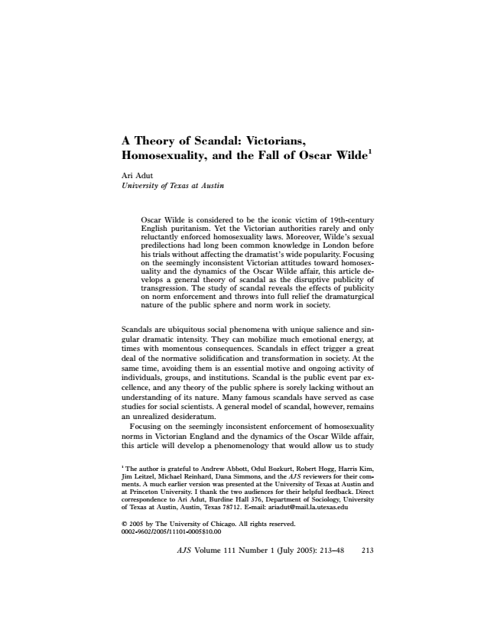
A Theory of Scandal: Victorians, Homosexuality, and the Fall of Oscar Wilde1
Ari Adut University of Texas at Austin
Oscar Wilde is considered to be the iconic victim of 19th-century English puritanism. Yet the Victorian authorities rarely and only reluctantly enforced homosexuality laws. Moreover, Wilde’s sexual predilections had long been common knowledge in London before his trials without affecting the dramatist’s wide popularity. Focusing on the seemingly inconsistent Victorian attitudes toward homosex- uality and the dynamics of the Oscar Wilde affair, this article de- velops a general theory of scandal as the disruptive publicity of transgression. The study of scandal reveals the effects of publicity on norm enforcement and throws into full relief the dramaturgical nature of the public sphere and norm work in society.
Scandals are ubiquitous social phenomena with unique salience and sin- gular dramatic intensity. They can mobilize much emotional energy, at times with momentous consequences. Scandals in effect trigger a great deal of the normative solidification and transformation in society. At the same time, avoiding them is an essential motive and ongoing activity of individuals, groups, and institutions. Scandal is the public event par ex- cellence, and any theory of the public sphere is sorely lacking without an understanding of its nature. Many famous scandals have served as case studies for social scientists. A general model of scandal, however, remains an unrealized desideratum.
Focusing on the seemingly inconsistent enforcement of homosexuality norms in Victorian England and the dynamics of the Oscar Wilde affair, this article will develop a phenomenology that would allow us to study
1 The author is grateful to Andrew Abbott, Odul Bozkurt, Robert Hogg, Harris Kim, Jim Leitzel, Michael Reinhard, Dana Simmons, and the AJS reviewers for their com- ments. A much earlier version was presented at the University of Texas at Austin and at Princeton University. I thank the two audiences for their helpful feedback. Direct correspondence to Ari Adut, Burdine Hall 376, Department of Sociology, University of Texas at Austin, Austin, Texas 78712. E-mail: ariadut@mail.la.utexas.edu
2005 by The University of Chicago. All rights reserved. 0002-9602/2005/11101-0005$10.00
AJS Volume 111 Number 1 (July 2005): 213–48 213

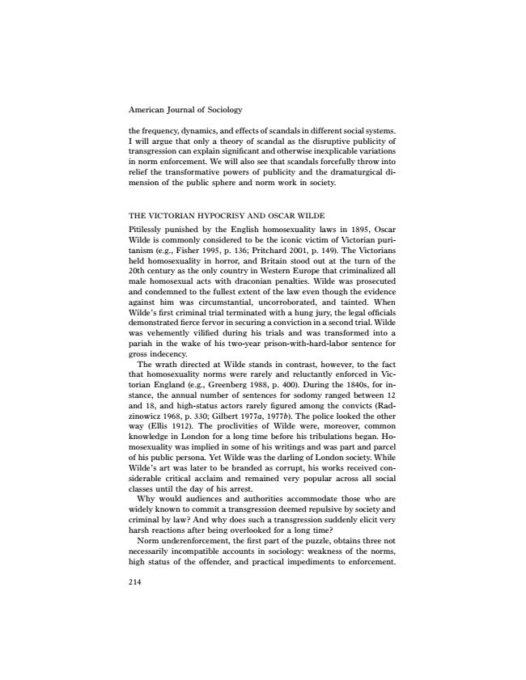
American Journal of Sociology
the frequency, dynamics, and effects of scandals in different social systems. I will argue that only a theory of scandal as the disruptive publicity of transgression can explain significant and otherwise inexplicable variations in norm enforcement. We will also see that scandals forcefully throw into relief the transformative powers of publicity and the dramaturgical di- mension of the public sphere and norm work in society.
THE VICTORIAN HYPOCRISY AND OSCAR WILDE Pitilessly punished by the English homosexuality laws in 1895, Oscar Wilde is commonly considered to be the iconic victim of Victorian puri- tanism (e.g., Fisher 1995, p. 136; Pritchard 2001, p. 149). The Victorians held homosexuality in horror, and Britain stood out at the turn of the 20th century as the only country in Western Europe that criminalized all male homosexual acts with draconian penalties. Wilde was prosecuted and condemned to the fullest extent of the law even though the evidence against him was circumstantial, uncorroborated, and tainted. When Wilde’s first criminal trial terminated with a hung jury, the legal officials demonstrated fierce fervor in securing a conviction in a second trial. Wilde was vehemently vilified during his trials and was transformed into a pariah in the wake of his two-year prison-with-hard-labor sentence for gross indecency.
The wrath directed at Wilde stands in contrast, however, to the fact that homosexuality norms were rarely and reluctantly enforced in Vic- torian England (e.g., Greenberg 1988, p. 400). During the 1840s, for in- stance, the annual number of sentences for sodomy ranged between 12 and 18, and high-status actors rarely figured among the convicts (Rad- zinowicz 1968, p. 330; Gilbert 1977a, 1977b). The police looked the other way (Ellis 1912). The proclivities of Wilde were, moreover, common knowledge in London for a long time before his tribulations began. Ho- mosexuality was implied in some of his writings and was part and parcel of his public persona. Yet Wilde was the darling of London society. While Wilde’s art was later to be branded as corrupt, his works received con- siderable critical acclaim and remained very popular across all social classes until the day of his arrest.
Why would audiences and authorities accommodate those who are widely known to commit a transgression deemed repulsive by society and criminal by law? And why does such a transgression suddenly elicit very harsh reactions after being overlooked for a long time?
Norm underenforcement, the first part of the puzzle, obtains three not necessarily incompatible accounts in sociology: weakness of the norms, high status of the offender, and practical impediments to enforcement.
214

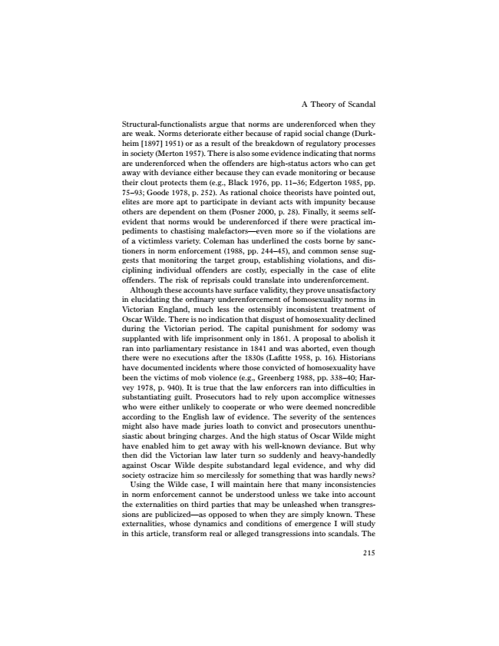
A Theory of Scandal
Structural-functionalists argue that norms are underenforced when they are weak. Norms deteriorate either because of rapid social change (Durk- heim [1897] 1951) or as a result of the breakdown of regulatory processes in society (Merton 1957). There is also some evidence indicating that norms are underenforced when the offenders are high-status actors who can get away with deviance either because they can evade monitoring or because their clout protects them (e.g., Black 1976, pp. 11–36; Edgerton 1985, pp. 75–93; Goode 1978, p. 252). As rational choice theorists have pointed out, elites are more apt to participate in deviant acts with impunity because others are dependent on them (Posner 2000, p. 28). Finally, it seems self- evident that norms would be underenforced if there were practical im- pediments to chastising malefactors—even more so if the violations are of a victimless variety. Coleman has underlined the costs borne by sanc- tioners in norm enforcement (1988, pp. 244–45), and common sense sug- gests that monitoring the target group, establishing violations, and dis- ciplining individual offenders are costly, especially in the case of elite offenders. The risk of reprisals could translate into underenforcement.
Although these accounts have surface validity, they prove unsatisfactory in elucidating the ordinary underenforcement of homosexuality norms in Victorian England, much less the ostensibly inconsistent treatment of Oscar Wilde. There is no indication that disgust of homosexuality declined during the Victorian period. The capital punishment for sodomy was supplanted with life imprisonment only in 1861. A proposal to abolish it ran into parliamentary resistance in 1841 and was aborted, even though there were no executions after the 1830s (Lafitte 1958, p. 16). Historians have documented incidents where those convicted of homosexuality have been the victims of mob violence (e.g., Greenberg 1988, pp. 338–40; Har- vey 1978, p. 940). It is true that the law enforcers ran into difficulties in substantiating guilt. Prosecutors had to rely upon accomplice witnesses who were either unlikely to cooperate or who were deemed noncredible according to the English law of evidence. The severity of the sentences might also have made juries loath to convict and prosecutors unenthu- siastic about bringing charges. And the high status of Oscar Wilde might have enabled him to get away with his well-known deviance. But why then did the Victorian law later turn so suddenly and heavy-handedly against Oscar Wilde despite substandard legal evidence, and why did society ostracize him so mercilessly for something that was hardly news? Using the Wilde case, I will maintain here that many inconsistencies in norm enforcement cannot be understood unless we take into account the externalities on third parties that may be unleashed when transgres- sions are publicized—as opposed to when they are simply known. These externalities, whose dynamics and conditions of emergence I will study in this article, transform real or alleged transgressions into scandals. The
215

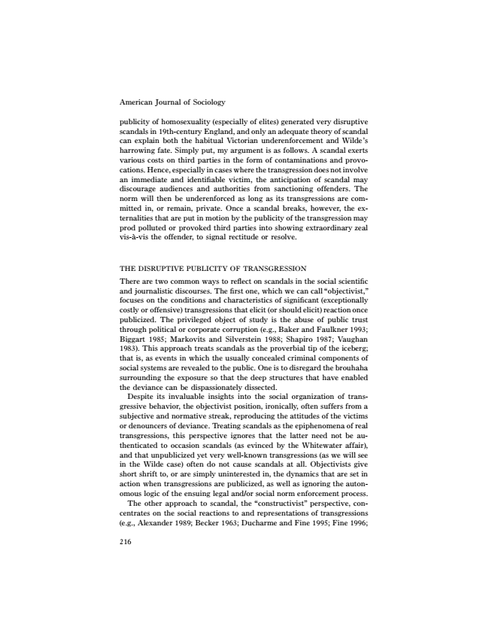
American Journal of Sociology
publicity of homosexuality (especially of elites) generated very disruptive scandals in 19th-century England, and only an adequate theory of scandal can explain both the habitual Victorian underenforcement and Wilde’s harrowing fate. Simply put, my argument is as follows. A scandal exerts various costs on third parties in the form of contaminations and provo- cations. Hence, especially in cases where the transgression does not involve an immediate and identifiable victim, the anticipation of scandal may discourage audiences and authorities from sanctioning offenders. The norm will then be underenforced as long as its transgressions are com- mitted in, or remain, private. Once a scandal breaks, however, the ex- ternalities that are put in motion by the publicity of the transgression may prod polluted or provoked third parties into showing extraordinary zeal vis-a`-vis the offender, to signal rectitude or resolve.
THE DISRUPTIVE PUBLICITY OF TRANSGRESSION There are two common ways to reflect on scandals in the social scientific and journalistic discourses. The first one, which we can call “objectivist,” focuses on the conditions and characteristics of significant (exceptionally costly or offensive) transgressions that elicit (or should elicit) reaction once publicized. The privileged object of study is the abuse of public trust through political or corporate corruption (e.g., Baker and Faulkner 1993; Biggart 1985; Markovits and Silverstein 1988; Shapiro 1987; Vaughan 1983). This approach treats scandals as the proverbial tip of the iceberg; that is, as events in which the usually concealed criminal components of social systems are revealed to the public. One is to disregard the brouhaha surrounding the exposure so that the deep structures that have enabled the deviance can be dispassionately dissected.
Despite its invaluable insights into the social organization of trans- gressive behavior, the objectivist position, ironically, often suffers from a subjective and normative streak, reproducing the attitudes of the victims or denouncers of deviance. Treating scandals as the epiphenomena of real transgressions, this perspective ignores that the latter need not be au- thenticated to occasion scandals (as evinced by the Whitewater affair), and that unpublicized yet very well-known transgressions (as we will see in the Wilde case) often do not cause scandals at all. Objectivists give short shrift to, or are simply uninterested in, the dynamics that are set in action when transgressions are publicized, as well as ignoring the auton- omous logic of the ensuing legal and/or social norm enforcement process. The other approach to scandal, the “constructivist” perspective, con- centrates on the social reactions to and representations of transgressions (e.g., Alexander 1989; Becker 1963; Ducharme and Fine 1995; Fine 1996;
216

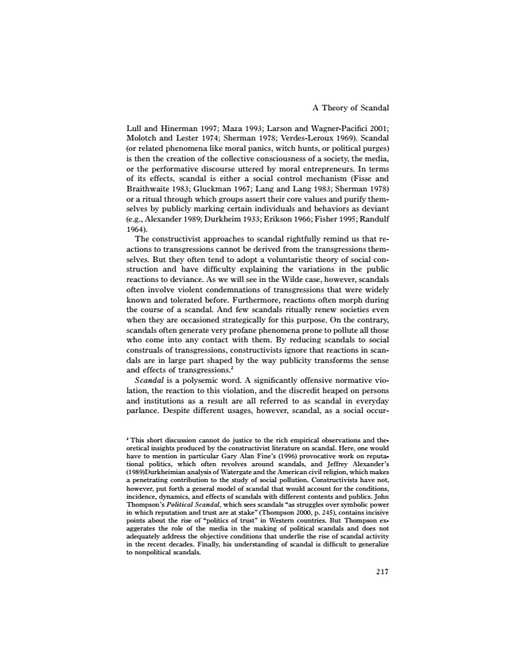
A Theory of Scandal
Lull and Hinerman 1997; Maza 1993; Larson and Wagner-Pacifici 2001; Molotch and Lester 1974; Sherman 1978; Verdes-Leroux 1969). Scandal (or related phenomena like moral panics, witch hunts, or political purges) is then the creation of the collective consciousness of a society, the media, or the performative discourse uttered by moral entrepreneurs. In terms of its effects, scandal is either a social control mechanism (Fisse and Braithwaite 1983; Gluckman 1967; Lang and Lang 1983; Sherman 1978) or a ritual through which groups assert their core values and purify them- selves by publicly marking certain individuals and behaviors as deviant (e.g., Alexander 1989; Durkheim 1933; Erikson 1966; Fisher 1995; Randulf 1964).
The constructivist approaches to scandal rightfully remind us that re- actions to transgressions cannot be derived from the transgressions them- selves. But they often tend to adopt a voluntaristic theory of social con- struction and have difficulty explaining the variations in the public reactions to deviance. As we will see in the Wilde case, however, scandals often involve violent condemnations of transgressions that were widely known and tolerated before. Furthermore, reactions often morph during the course of a scandal. And few scandals ritually renew societies even when they are occasioned strategically for this purpose. On the contrary, scandals often generate very profane phenomena prone to pollute all those who come into any contact with them. By reducing scandals to social construals of transgressions, constructivists ignore that reactions in scan- dals are in large part shaped by the way publicity transforms the sense and effects of transgressions.2
Scandal is a polysemic word. A significantly offensive normative vio- lation, the reaction to this violation, and the discredit heaped on persons and institutions as a result are all referred to as scandal in everyday parlance. Despite different usages, however, scandal, as a social occur-
2 This short discussion cannot do justice to the rich empirical observations and the- oretical insights produced by the constructivist literature on scandal. Here, one would have to mention in particular Gary Alan Fine’s (1996) provocative work on reputa- tional politics, which often revolves around scandals, and Jeffrey Alexander’s (1989)Durkheimian analysis of Watergate and the American civil religion, which makes a penetrating contribution to the study of social pollution. Constructivists have not, however, put forth a general model of scandal that would account for the conditions, incidence, dynamics, and effects of scandals with different contents and publics. John Thompson’s Political Scandal, which sees scandals “as struggles over symbolic power in which reputation and trust are at stake” (Thompson 2000, p. 245), contains incisive points about the rise of “politics of trust” in Western countries. But Thompson ex- aggerates the role of the media in the making of political scandals and does not adequately address the objective conditions that underlie the rise of scandal activity in the recent decades. Finally, his understanding of scandal is difficult to generalize to nonpolitical scandals.
217

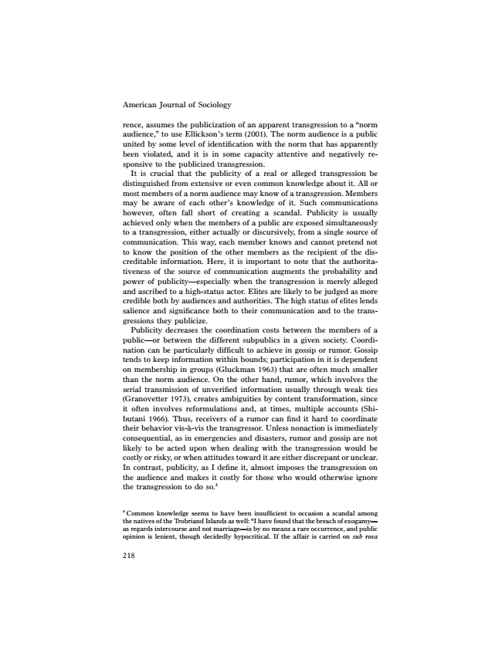
American Journal of Sociology
rence, assumes the publicization of an apparent transgression to a “norm audience,” to use Ellickson’s term (2001). The norm audience is a public united by some level of identification with the norm that has apparently been violated, and it is in some capacity attentive and negatively re- sponsive to the publicized transgression.
It is crucial that the publicity of a real or alleged transgression be distinguished from extensive or even common knowledge about it. All or most members of a norm audience may know of a transgression. Members may be aware of each other’s knowledge of it. Such communications however, often fall short of creating a scandal. Publicity is usually achieved only when the members of a public are exposed simultaneously to a transgression, either actually or discursively, from a single source of communication. This way, each member knows and cannot pretend not to know the position of the other members as the recipient of the dis- creditable information. Here, it is important to note that the authorita- tiveness of the source of communication augments the probability and power of publicity—especially when the transgression is merely alleged and ascribed to a high-status actor. Elites are likely to be judged as more credible both by audiences and authorities. The high status of elites lends salience and significance both to their communication and to the trans- gressions they publicize.
Publicity decreases the coordination costs between the members of a public—or between the different subpublics in a given society. Coordi- nation can be particularly difficult to achieve in gossip or rumor. Gossip tends to keep information within bounds; participation in it is dependent on membership in groups (Gluckman 1963) that are often much smaller than the norm audience. On the other hand, rumor, which involves the serial transmission of unverified information usually through weak ties (Granovetter 1973), creates ambiguities by content transformation, since it often involves reformulations and, at times, multiple accounts (Shi- butani 1966). Thus, receivers of a rumor can find it hard to coordinate their behavior vis-a`-vis the transgressor. Unless nonaction is immediately consequential, as in emergencies and disasters, rumor and gossip are not likely to be acted upon when dealing with the transgression would be costly or risky, or when attitudes toward it are either discrepant or unclear. In contrast, publicity, as I define it, almost imposes the transgression on the audience and makes it costly for those who would otherwise ignore the transgression to do so.3
3 Common knowledge seems to have been insufficient to occasion a scandal among the natives of the Trobriand Islands as well: “I have found that the breach of exogamy— as regards intercourse and not marriage—is by no means a rare occurrence, and public opinion is lenient, though decidedly hypocritical. If the affair is carried on sub rosa
218

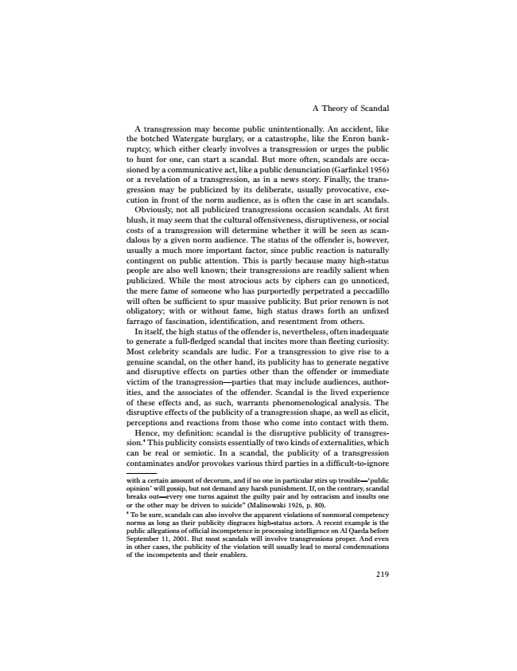
A Theory of Scandal
A transgression may become public unintentionally. An accident, like the botched Watergate burglary, or a catastrophe, like the Enron bank- ruptcy, which either clearly involves a transgression or urges the public to hunt for one, can start a scandal. But more often, scandals are occa- sioned by a communicative act, like a public denunciation (Garfinkel 1956) or a revelation of a transgression, as in a news story. Finally, the trans- gression may be publicized by its deliberate, usually provocative, exe- cution in front of the norm audience, as is often the case in art scandals. Obviously, not all publicized transgressions occasion scandals. At first blush, it may seem that the cultural offensiveness, disruptiveness, or social costs of a transgression will determine whether it will be seen as scan- dalous by a given norm audience. The status of the offender is, however, usually a much more important factor, since public reaction is naturally contingent on public attention. This is partly because many high-status people are also well known; their transgressions are readily salient when publicized. While the most atrocious acts by ciphers can go unnoticed, the mere fame of someone who has purportedly perpetrated a peccadillo will often be sufficient to spur massive publicity. But prior renown is not obligatory; with or without fame, high status draws forth an unfixed farrago of fascination, identification, and resentment from others.
In itself, the high status of the offender is, nevertheless, often inadequate to generate a full-fledged scandal that incites more than fleeting curiosity. Most celebrity scandals are ludic. For a transgression to give rise to a genuine scandal, on the other hand, its publicity has to generate negative and disruptive effects on parties other than the offender or immediate victim of the transgression—parties that may include audiences, author- ities, and the associates of the offender. Scandal is the lived experience of these effects and, as such, warrants phenomenological analysis. The disruptive effects of the publicity of a transgression shape, as well as elicit, perceptions and reactions from those who come into contact with them. Hence, my definition: scandal is the disruptive publicity of transgres- sion.4 This publicity consists essentially of two kinds of externalities, which can be real or semiotic. In a scandal, the publicity of a transgression contaminates and/or provokes various third parties in a difficult-to-ignore
with a certain amount of decorum, and if no one in particular stirs up trouble—‘public opinion’ will gossip, but not demand any harsh punishment. If, on the contrary, scandal breaks out—every one turns against the guilty pair and by ostracism and insults one or the other may be driven to suicide” (Malinowski 1926, p. 80). 4 To be sure, scandals can also involve the apparent violations of nonmoral competency norms as long as their publicity disgraces high-status actors. A recent example is the public allegations of official incompetence in processing intelligence on Al Qaeda before September 11, 2001. But most scandals will involve transgressions proper. And even in other cases, the publicity of the violation will usually lead to moral condemnations of the incompetents and their enablers.
219

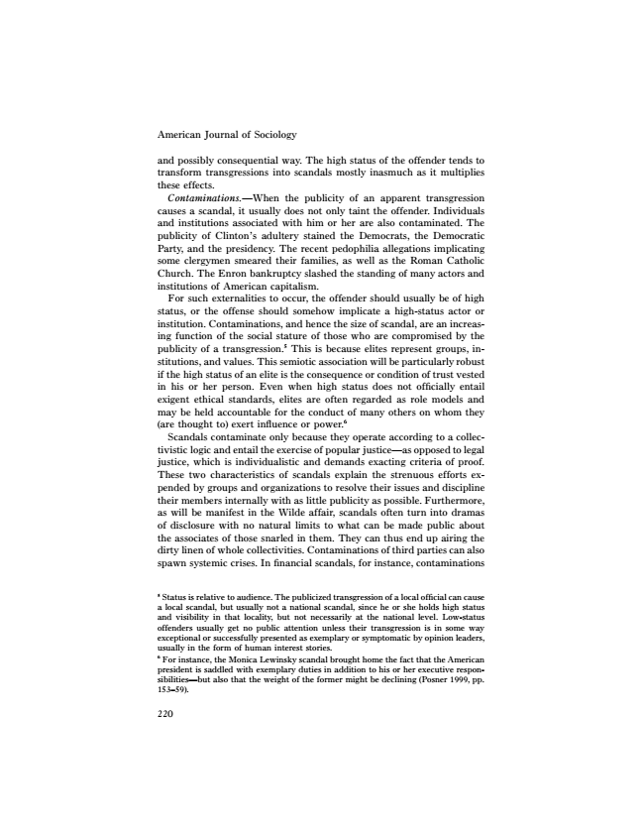
American Journal of Sociology
and possibly consequential way. The high status of the offender tends to transform transgressions into scandals mostly inasmuch as it multiplies these effects.
Contaminations.—When the publicity of an apparent transgression causes a scandal, it usually does not only taint the offender. Individuals and institutions associated with him or her are also contaminated. The publicity of Clinton’s adultery stained the Democrats, the Democratic Party, and the presidency. The recent pedophilia allegations implicating some clergymen smeared their families, as well as the Roman Catholic Church. The Enron bankruptcy slashed the standing of many actors and institutions of American capitalism.
For such externalities to occur, the offender should usually be of high status, or the offense should somehow implicate a high-status actor or institution. Contaminations, and hence the size of scandal, are an increas- ing function of the social stature of those who are compromised by the publicity of a transgression.5 This is because elites represent groups, in- stitutions, and values. This semiotic association will be particularly robust if the high status of an elite is the consequence or condition of trust vested in his or her person. Even when high status does not officially entail exigent ethical standards, elites are often regarded as role models and may be held accountable for the conduct of many others on whom they (are thought to) exert influence or power.6
Scandals contaminate only because they operate according to a collec- tivistic logic and entail the exercise of popular justice—as opposed to legal justice, which is individualistic and demands exacting criteria of proof. These two characteristics of scandals explain the strenuous efforts ex- pended by groups and organizations to resolve their issues and discipline their members internally with as little publicity as possible. Furthermore, as will be manifest in the Wilde affair, scandals often turn into dramas of disclosure with no natural limits to what can be made public about the associates of those snarled in them. They can thus end up airing the dirty linen of whole collectivities. Contaminations of third parties can also spawn systemic crises. In financial scandals, for instance, contaminations
5 Status is relative to audience. The publicized transgression of a local official can cause a local scandal, but usually not a national scandal, since he or she holds high status and visibility in that locality, but not necessarily at the national level. Low-status offenders usually get no public attention unless their transgression is in some way exceptional or successfully presented as exemplary or symptomatic by opinion leaders, usually in the form of human interest stories. 6 For instance, the Monica Lewinsky scandal brought home the fact that the American president is saddled with exemplary duties in addition to his or her executive respon- sibilities—but also that the weight of the former might be declining (Posner 1999, pp. 153–59).
220

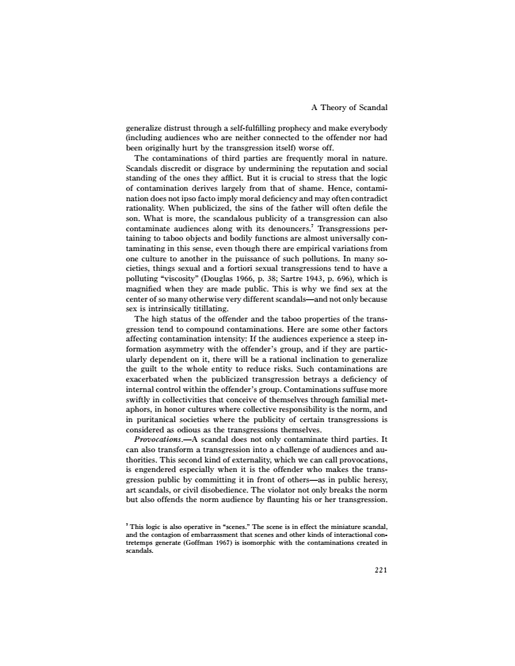
A Theory of Scandal
generalize distrust through a self-fulfilling prophecy and make everybody (including audiences who are neither connected to the offender nor had been originally hurt by the transgression itself) worse off.
The contaminations of third parties are frequently moral in nature. Scandals discredit or disgrace by undermining the reputation and social standing of the ones they afflict. But it is crucial to stress that the logic of contamination derives largely from that of shame. Hence, contami- nation does not ipso facto imply moral deficiency and may often contradict rationality. When publicized, the sins of the father will often defile the son. What is more, the scandalous publicity of a transgression can also contaminate audiences along with its denouncers.7 Transgressions per- taining to taboo objects and bodily functions are almost universally con- taminating in this sense, even though there are empirical variations from one culture to another in the puissance of such pollutions. In many so- cieties, things sexual and a fortiori sexual transgressions tend to have a polluting “viscosity” (Douglas 1966, p. 38; Sartre 1943, p. 696), which is magnified when they are made public. This is why we find sex at the center of so many otherwise very different scandals—and not only because sex is intrinsically titillating.
The high status of the offender and the taboo properties of the trans- gression tend to compound contaminations. Here are some other factors affecting contamination intensity: If the audiences experience a steep in- formation asymmetry with the offender’s group, and if they are partic- ularly dependent on it, there will be a rational inclination to generalize the guilt to the whole entity to reduce risks. Such contaminations are exacerbated when the publicized transgression betrays a deficiency of internal control within the offender’s group. Contaminations suffuse more swiftly in collectivities that conceive of themselves through familial met- aphors, in honor cultures where collective responsibility is the norm, and in puritanical societies where the publicity of certain transgressions is considered as odious as the transgressions themselves.
Provocations.—A scandal does not only contaminate third parties. It can also transform a transgression into a challenge of audiences and au- thorities. This second kind of externality, which we can call provocations, is engendered especially when it is the offender who makes the trans- gression public by committing it in front of others—as in public heresy, art scandals, or civil disobedience. The violator not only breaks the norm but also offends the norm audience by flaunting his or her transgression.
7 This logic is also operative in “scenes.” The scene is in effect the miniature scandal, and the contagion of embarrassment that scenes and other kinds of interactional con- tretemps generate (Goffman 1967) is isomorphic with the contaminations created in scandals.
221

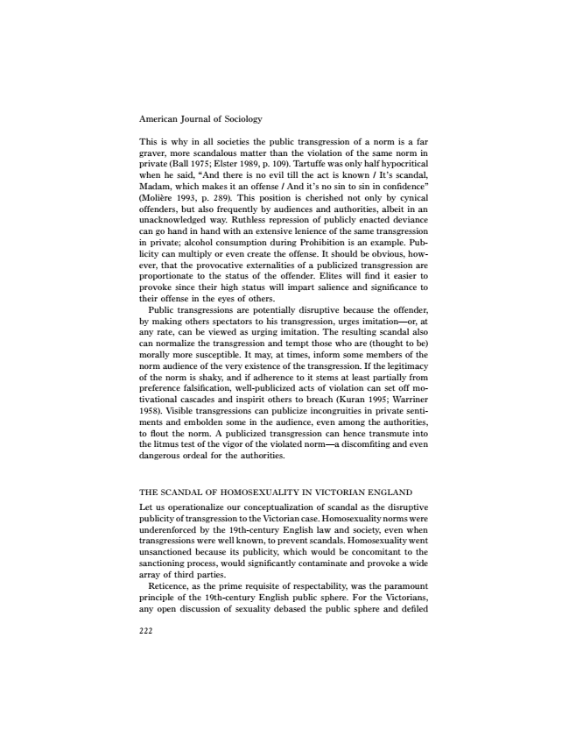
American Journal of Sociology
This is why in all societies the public transgression of a norm is a far graver, more scandalous matter than the violation of the same norm in private (Ball 1975; Elster 1989, p. 109). Tartuffe was only half hypocritical when he said, “And there is no evil till the act is known / It’s scandal, Madam, which makes it an offense / And it’s no sin to sin in confidence” (Molie`re 1993, p. 289). This position is cherished not only by cynical offenders, but also frequently by audiences and authorities, albeit in an unacknowledged way. Ruthless repression of publicly enacted deviance can go hand in hand with an extensive lenience of the same transgression in private; alcohol consumption during Prohibition is an example. Pub- licity can multiply or even create the offense. It should be obvious, how- ever, that the provocative externalities of a publicized transgression are proportionate to the status of the offender. Elites will find it easier to provoke since their high status will impart salience and significance to their offense in the eyes of others.
Public transgressions are potentially disruptive because the offender, by making others spectators to his transgression, urges imitation—or, at any rate, can be viewed as urging imitation. The resulting scandal also can normalize the transgression and tempt those who are (thought to be) morally more susceptible. It may, at times, inform some members of the norm audience of the very existence of the transgression. If the legitimacy of the norm is shaky, and if adherence to it stems at least partially from preference falsification, well-publicized acts of violation can set off mo- tivational cascades and inspirit others to breach (Kuran 1995; Warriner 1958). Visible transgressions can publicize incongruities in private senti- ments and embolden some in the audience, even among the authorities, to flout the norm. A publicized transgression can hence transmute into the litmus test of the vigor of the violated norm—a discomfiting and even dangerous ordeal for the authorities.
THE SCANDAL OF HOMOSEXUALITY IN VICTORIAN ENGLAND Let us operationalize our conceptualization of scandal as the disruptive publicity of transgression to the Victorian case. Homosexuality norms were underenforced by the 19th-century English law and society, even when transgressions were well known, to prevent scandals. Homosexuality went unsanctioned because its publicity, which would be concomitant to the sanctioning process, would significantly contaminate and provoke a wide array of third parties.
Reticence, as the prime requisite of respectability, was the paramount principle of the 19th-century English public sphere. For the Victorians, any open discussion of sexuality debased the public sphere and defiled
222

